Nama : Cepi Muhammad Rizky

Nim : 177200034

1. Pengetesan real time face detected

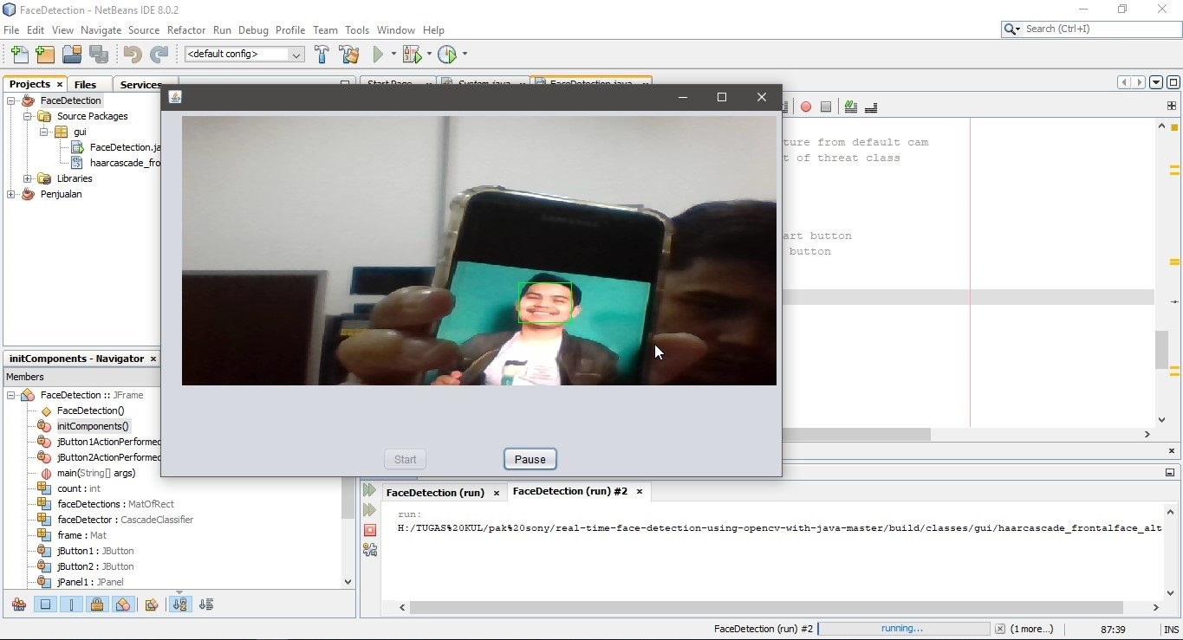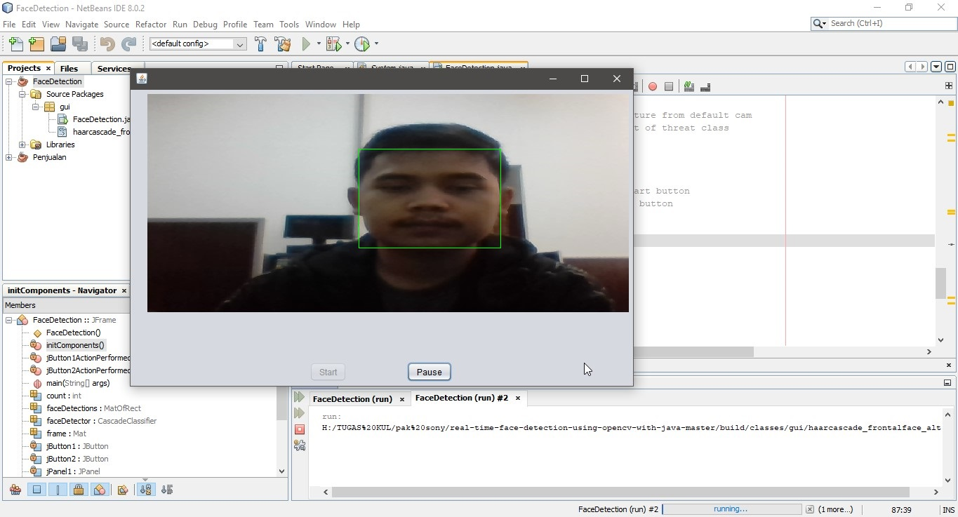

1. Coding

package gui;

import java.awt.Graphics;

import java.awt.Image;

import java.awt.image.BufferedImage;

import java.io.ByteArrayInputStream;

import javax.imageio.ImageIO;

import org.opencv.core.Core;

import org.opencv.core.Mat;

import org.opencv.core.MatOfByte;

import org.opencv.core.MatOfRect;

import org.opencv.core.Point;

import org.opencv.core.Rect;

import org.opencv.core.Scalar;

import org.opencv.core.Size;

import org.opencv.highgui.Highgui;

import org.opencv.highgui.VideoCapture;

import org.opencv.imgproc.Imgproc;

import org.opencv.objdetect.CascadeClassifier;

public class FaceDetection extends javax.swing.JFrame {

///

private DaemonThread myThread = null;

int count = 0;

VideoCapture webSource = null;

Mat frame = new Mat();

MatOfByte mem = new MatOfByte();

CascadeClassifier faceDetector = new CascadeClassifier(FaceDetection.class.getResource("haarcascade_frontalface_alt.xml").getPath().substring(1));

MatOfRect faceDetections = new MatOfRect();

///

class DaemonThread implements Runnable {

protected volatile boolean runnable = false;

@Override

public void run() {

synchronized (this) {

while (runnable) {

if (webSource.grab()) {

try {

webSource.retrieve(frame);

Graphics g = jPanel1.getGraphics();

faceDetector.detectMultiScale(frame, faceDetections);

for (Rect rect : faceDetections.toArray()) {

// System.out.println("ttt");

Core.rectangle(frame, new Point(rect.x, rect.y), new Point(rect.x + rect.width, rect.y + rect.height),

new Scalar(0, 255,0));

}

Highgui.imencode(".bmp", frame, mem);

Image im = ImageIO.read(new ByteArrayInputStream(mem.toArray()));

BufferedImage buff = (BufferedImage) im;

if (g.drawImage(buff, 0, 0, getWidth(), getHeight()-150 , 0, 0, buff.getWidth(), buff.getHeight(), null)) {

if (runnable == false) {

System.out.println("Paused ..... ");

this.wait();

}

}

} catch (Exception ex) {

System.out.println("Error!!");

ex.printStackTrace();

}

}

}

}

}

}

/////////

public FaceDetection() {

initComponents();

System.out.println(FaceDetection.class.getResource("haarcascade_frontalface_alt.xml").getPath().substring(1));

}

@SuppressWarnings("unchecked")

// <editor-fold defaultstate="collapsed" desc="Generated Code">

private void initComponents() {

jPanel1 = new javax.swing.JPanel();

jButton1 = new javax.swing.JButton();

jButton2 = new javax.swing.JButton();

setDefaultCloseOperation(javax.swing.WindowConstants.EXIT_ON_CLOSE);

javax.swing.GroupLayout jPanel1Layout = new javax.swing.GroupLayout(jPanel1);

jPanel1.setLayout(jPanel1Layout);

jPanel1Layout.setHorizontalGroup(

jPanel1Layout.createParallelGroup(javax.swing.GroupLayout.Alignment.LEADING)

.addGap(0, 0, Short.MAX_VALUE)

);

jPanel1Layout.setVerticalGroup(

jPanel1Layout.createParallelGroup(javax.swing.GroupLayout.Alignment.LEADING)

.addGap(0, 376, Short.MAX_VALUE)

);

jButton1.setText("Start");

jButton1.addActionListener(new java.awt.event.ActionListener() {

public void actionPerformed(java.awt.event.ActionEvent evt) {

jButton1ActionPerformed(evt);

}

});

jButton2.setText("Pause");

jButton2.addActionListener(new java.awt.event.ActionListener() {

public void actionPerformed(java.awt.event.ActionEvent evt) {

jButton2ActionPerformed(evt);

}

});

javax.swing.GroupLayout layout = new javax.swing.GroupLayout(getContentPane());

getContentPane().setLayout(layout);

layout.setHorizontalGroup(

layout.createParallelGroup(javax.swing.GroupLayout.Alignment.LEADING)

.addGroup(layout.createSequentialGroup()

.addGap(24, 24, 24)

.addComponent(jPanel1, javax.swing.GroupLayout.DEFAULT_SIZE, javax.swing.GroupLayout.DEFAULT_SIZE, Short.MAX_VALUE)

.addContainerGap())

.addGroup(layout.createSequentialGroup()

.addGap(255, 255, 255)

.addComponent(jButton1)

.addGap(86, 86, 86)

.addComponent(jButton2)

.addContainerGap(258, Short.MAX_VALUE))

);

layout.setVerticalGroup(

layout.createParallelGroup(javax.swing.GroupLayout.Alignment.LEADING)

.addGroup(layout.createSequentialGroup()

.addContainerGap()

.addComponent(jPanel1, javax.swing.GroupLayout.PREFERRED_SIZE, javax.swing.GroupLayout.DEFAULT_SIZE, javax.swing.GroupLayout.PREFERRED_SIZE)

.addPreferredGap(javax.swing.LayoutStyle.ComponentPlacement.RELATED)

.addGroup(layout.createParallelGroup(javax.swing.GroupLayout.Alignment.BASELINE)

.addComponent(jButton1)

.addComponent(jButton2))

.addContainerGap(javax.swing.GroupLayout.DEFAULT_SIZE, Short.MAX_VALUE))

);

pack();

}// </editor-fold>

private void jButton2ActionPerformed(java.awt.event.ActionEvent evt) {

myThread.runnable = false; // stop thread

jButton2.setEnabled(false); // activate start button

jButton1.setEnabled(true); // deactivate stop button

webSource.release(); // stop caturing fron cam

}

private void jButton1ActionPerformed(java.awt.event.ActionEvent evt) {

webSource = new VideoCapture(0); // video capture from default cam

myThread = new DaemonThread(); //create object of threat class

Thread t = new Thread(myThread);

t.setDaemon(true);

myThread.runnable = true;

t.start(); //start thrad

jButton1.setEnabled(false); // deactivate start button

jButton2.setEnabled(true); // activate stop button

}

/**

* @param args the command line arguments

*/

public static void main(String args[]) {

System.loadLibrary(Core.NATIVE_LIBRARY_NAME);

/* Set the Nimbus look and feel */

//<editor-fold defaultstate="collapsed" desc=" Look and feel setting code (optional) ">

/* If Nimbus (introduced in Java SE 6) is not available, stay with the default look and feel.

* For details see http://download.oracle.com/javase/tutorial/uiswing/lookandfeel/plaf.html

*/

try {

for (javax.swing.UIManager.LookAndFeelInfo info : javax.swing.UIManager.getInstalledLookAndFeels()) {

if ("Nimbus".equals(info.getName())) {

javax.swing.UIManager.setLookAndFeel(info.getClassName());

break;

}

}

} catch (ClassNotFoundException ex) {

java.util.logging.Logger.getLogger(FaceDetection.class.getName()).log(java.util.logging.Level.SEVERE, null, ex);

} catch (InstantiationException ex) {

java.util.logging.Logger.getLogger(FaceDetection.class.getName()).log(java.util.logging.Level.SEVERE, null, ex);

} catch (IllegalAccessException ex) {

java.util.logging.Logger.getLogger(FaceDetection.class.getName()).log(java.util.logging.Level.SEVERE, null, ex);

} catch (javax.swing.UnsupportedLookAndFeelException ex) {

java.util.logging.Logger.getLogger(FaceDetection.class.getName()).log(java.util.logging.Level.SEVERE, null, ex);

}

//</editor-fold>

/* Create and display the form */

java.awt.EventQueue.invokeLater(new Runnable() {

public void run() {

new FaceDetection().setVisible(true);

}

});

}

// Variables declaration - do not modify

private javax.swing.JButton jButton1;

private javax.swing.JButton jButton2;

private javax.swing.JPanel jPanel1;

// End of variables declaration

}